Genetic Analysis of Congenital Anomalies and Neurodevelopmental Impairment in a Consanguineous Pedigree

Shadi Shams Zahraee
Helix Institute for Medical & Biological Sciences, Texas, USA
https://www.helixinstitute.us/
Genomics Comprehensive Research Laboratory, Tehran, Iran
https://www.genomicslaboratory.ir/

Project Overview
This case study describes the manual filtering, review, and prioritization of genetic variants identified in a consanguineous pedigree affected by congenital anomalies and neurodevelopmental impairment.
The analysis was performed using an annotated variant table derived from a targeted next-generation sequencing (NGS) panel. The available dataset was generated from the proband and contained extensive variant-level annotations from multiple genomic, population, clinical, and computational resources.
The primary aim of the analysis was to systematically reduce the initial set of annotated variants and identify those potentially relevant to the reported clinical phenotype and suspected mode of inheritance.

Case Context
Pedigree and Clinical Findings (Summary):
The family is consanguineous, with two affected siblings (V:1 and V:4) and no reported history of a similar disorder in other relatives. The proband, V:1, is male.
Shared clinical features in both affected individuals:
- Neurodevelopmental impairment (developmental delay, trainable intellectual disability)
- Visual impairment
- Unclear speech
- Microcephaly:
  - V:1 (proband, male, age 32): OFC 51 cm → −2.77 SD
  - V:4 (female, age 30): OFC 50 cm → −4.07 SD
Distinguishing feature:
- Cleft palate was reported only in the proband (V:1).
Other pedigree members:
- One unaffected male sibling
- One unaffected individual in the subsequent generation
Based on the available pedigree structure (Figure 1), particular attention was given to variants potentially compatible with an autosomal recessive mode of inheritance.

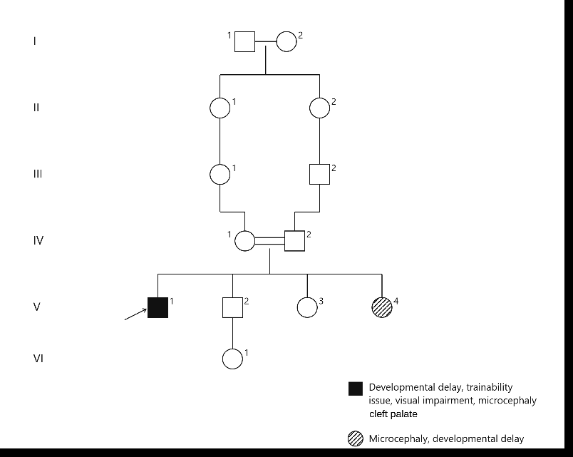
Figure 1. Pedigree of the studied consanguineous family showing affected and unaffected individuals

Available Data
The analysis was based on a single annotated Excel worksheet derived from a targeted NGS panel VCF. Variant-level data were available only for the proband (V:1), while raw sequencing and VCF files were unavailable. Therefore, the analysis focused on downstream variant filtering, interpretation, and prioritization.
The annotated dataset contained genomic and gene-level information, including chromosome and genomic coordinates, reference/alternate alleles, gene and region annotations, functional consequences, amino acid and transcript-level annotations, cytogenetic location, dbSNP/variant identifiers, and zygosity. In silico functional predictions included SIFT, PolyPhen-2, LRT, MutationTaster, MutationAssessor, FATHMM, PROVEAN, VEST3, MetaSVM, MetaLR, M-CAP, CADD, DANN, Eigen, GenoCanyon, and integrated fitCons. Evolutionary conservation scores included GERP++, phyloP, phastCons, and SiPhy. Additional annotations comprised protein domains, splice prediction scores, and population frequency data from ESP6500, ExAC, Kaviar, HRC, and 1000 Genomes. Clinical annotations were obtained from ClinVar, including clinical significance and disease associations. The dataset also included automated InterVar classifications and individual ACMG/AMP evidence codes. These annotations were used for subsequent variant filtering and manual candidate prioritization.

Objective and Resources Used
This analysis aimed to filter and prioritize variants from an annotated targeted NGS dataset to identify candidates consistent with the clinical phenotype and suspected inheritance pattern.
Variant interpretation drew on multiple resources: population frequency (gnomAD, ExAC, 1000 Genomes), clinical significance (ClinVar, InterVar), gene–disease and phenotype associations (OMIM, HPO), literature (PubMed), and gene/transcript annotation (Ensembl, NCBI). In silico predictors, conservation scores, and other dataset annotations were also incorporated.

Analysis Workflow
The analysis followed a stepwise variant prioritization strategy, beginning with the annotated variant dataset from the proband. Each filtering step was based on specific genomic, functional, clinical, population, or inheritance-related criteria.
Step 1 – Initial genomic and functional filtering
The annotated variant dataset was initially reviewed for genomic location and functional consequence. Non-exonic variants were excluded, while exonic, splicing, and exonic-splicing variants were retained for further analysis.
Step 2 – Inheritance-based zygosity filtering
Based on the consanguineous pedigree and the suspected autosomal recessive inheritance pattern, heterozygous variants were initially excluded and homozygous variants were prioritized for analysis.
Step 3 – Population frequency filtering
Variants with an ExAC allele frequency >5% were excluded. Although this threshold is relatively permissive, a higher frequency was considered inconsistent with a rare Mendelian disorder and therefore variants above this cutoff were removed.
Step 4 – Clinical significance filtering
Variants annotated as Benign or Likely Benign by InterVar were excluded. ClinVar clinical significance was not used as a direct filtering criterion at this stage because conflicting classifications were present and required individual database-level reassessment.
Step 5 – Variant quality filtering
Variant-level sequencing quality was assessed, and only variants meeting the available PASS quality criterion were retained for downstream analysis.
Result: 55 variants in 39 genes.
Step 6 – Additional InterVar filtering
Benign and Likely Benign variants according to InterVar were further excluded following review of the available classifications.
Result: 45 variants in 37 genes.
Step 7 – Read-depth and allele-depth assessment
Variants were further evaluated based on sequencing read support. Variants with DP >20 were retained, while AD <10 was considered insufficient support and triggered additional manual review rather than automatic acceptance.
Result: 30 variants.
Step 8 – Chromosome X assessment
Because the pedigree was most consistent with an autosomal recessive disorder and both affected individuals were of different sexes, X-linked inheritance was considered less compatible with the observed pattern. X-chromosome variants were therefore excluded from the primary autosomal-recessive analysis. However, X-linked variants were subsequently reviewed separately for inheritance and phenotype compatibility; no strong phenotype-compatible candidate was identified. These variants were retained for reference in the Main Sheet 2 – X.
Step 9 – Additional population-frequency assessment
Variants with a population frequency >1% were subjected to additional manual review. Given the rarity of the suspected disorder, such frequencies were considered relatively high and were evaluated with respect to both genotype and phenotype before exclusion.
Result: 13 variants remained.
Step 10 – Variant-level database assessment
The remaining 13 variants were individually investigated using multiple genomic and clinical databases to assess their genotypic evidence, population frequency, clinical classification, computational predictions, gene–disease relationships, and available literature.
Step 11 – Phenotypic assessment of candidate variants
Each remaining variant was evaluated against the patient's phenotype and the reported phenotype of the corresponding gene–disease association. Particular attention was given to whether the variant could explain all or part of the observed phenotype, rather than requiring a single variant to account for the entire clinical presentation (Table 1).

Results:

Table1: Variant Prioritization

Gene | Variant / Zygosity / Type | In silico (SIFT/PolyPhen) | Pop. AF (ExAC/gnomAD) | ClinVar/ACMG | Inheritance | Gene–disease, phenotype & notes | Final decision & reason
POGK | c.494G>C (p.S165T)  Homozygous — Nonsyn. SNV | T (0.789) / B (0.001) | ~0.0023 / 0.0021 | VUS | — | No established OMIM disease association | Deprioritize — tolerated + benign + not ultra-rare
CRTC2 | c.G1286A (p.R429H)  Homozygous — Nonsyn. SNV | T (0.196) / B (0.002) | ~0.0002 / 8.45E-05 | VUS | — | No established OMIM disease association | Deprioritize — tolerated + benign
YY1AP1 | c.T1373G (p.L458R)  Homozygous — Nonsyn. SNV | D (0.005) / D (0.988) | Absent / 8.26E-06 | VUS | AR | Grange syndrome (AR): vascular stenoses, brachy/syndactyly, learning difficulty. Partial phenotype overlap (ID); vascular/limb features not reported — verify before ruling in/out. | Prioritize — damaging + very rare AF; confirm vascular/skeletal phenotype
KRTAP5-5 | c.158_159ins26bp (pA53fs)  Homozygous — Frameshift ins. | — | ~0.0097 / 0.0045 | — | — | Keratin-associated protein (hair) — no neurodevelopmental link | Deprioritize — frequent + gene unrelated to phenotype
KRTAP5-5 | c.156_157insGGAG (p.C52fs)  Homozygous — Frameshift ins. | — | ~0.0027 / 0.0007 | — | — | Keratin-associated protein — no neurodevelopmental link | Deprioritize/review — AF not ultra-rare + unrelated gene
MAML2 | c.1941_1961del (p.647_654del)  Homozygous — In-frame del. | — | ~0.0019 / 0.0024 | — | — | Somatic driver (mucoepidermoid carcinoma translocations); no germline recessive disease established | Deprioritize/review — measurable AF, no germline link
LTBP1 | c.G2111A (p.R704Q)  Homozygous — Nonsyn. SNV | T (0.154) / B (0.019) | ~0.0032 / 0.0065 | VUS | AR | Geleophysic/cutis-laxa-like (AR): short stature, skin laxity — not reported in proband | Deprioritize — tolerated/benign + relatively high AF
VRK2 | c.T1504C (p.F502L)  Homozygous — Nonsyn. SNV | T (0.962) / B (0.001) | ~0.011 / 0.007 | VUS | — | GWAS-level link to epilepsy/psychiatric traits; not an established Mendelian gene | Deprioritize — high AF + benign predictions
C2orf71  (PCARE) | c.G2191A (p.V731I)  Homozygous — Nonsyn. SNV | D (0) / D (0.989) | ~8.10E-05 / 0.0005 | VUS | AR | Retinitis pigmentosa 54 (AR) — established recessive retinal-dystrophy gene. Good match with reported visual impairment; recommend ERG/fundus exam. | Prioritize — damaging + rare AF + phenotype match
VSTM2L | c.C275T (p.A92V)  Homozygous — Nonsyn. SNV | T (0.269) / B (0.355) | ~0.011 / 0.007 | VUS | — | No established OMIM disease association | Deprioritize — common + tolerated/benign
AUTS2 | c.3302_3303insCCA (p.S1101delinsSH)  Homozygous — In-frame ins. | — | ~0.0072 / 0.0098 | VUS | AD* | AUTS2 syndrome is classically autosomal DOMINANT (de novo heterozygous). Phenotype overlaps (autism, DD) but homozygosity conflicts with known mechanism. | Deprioritize/review — mechanism mismatch + relatively high AF
KDM7A | c.C2690T (p.P897L)  Homozygous — Nonsyn. SNV | D (0.013) / B (0.018) | ~0.002 / 0.0042 | VUS | — | Not a confirmed OMIM disease gene; some role in neural differentiation | Review — mixed predictions + AF not extremely rare
PUM3 | c.T1350A (p.D450E)  Homozygous — Nonsyn. SNV | D (0.02) / D (0.966) | ~0.0005 / 0.0004 | VUS | — | Not yet an established OMIM disease gene; PUF-family RNA-binding protein, plausible neurodevelopmental role | Prioritize — damaging + rare AF; candidate pending further evidence

After filtering 13 variants, four candidate variants in YY1AP1, C2orf71, KDM7A, and PUM3 were selected based on their genotype and partial phenotypic concordance with the pedigree. These variants were further evaluated using population databases, disease and phenotype databases, ancestry-specific data, and relevant literature.

YY1AP1: YY1AP1 is associated with Grange syndrome, a rare autosomal recessive disorder characterized primarily by progressive vascular disease, hypertension, skeletal abnormalities, and variable neurodevelopmental impairment (1)(2). A rare homozygous YY1AP1 variant with an extremely low frequency in gnomAD was identified in the affected individual. Developmental delay/intellectual impairment and speech difficulties provide partial phenotypic overlap, although microcephaly, visual impairment, and cleft palate are not established core features, and characteristic vascular and skeletal manifestations have not been observed. Importantly, vascular abnormalities may not be clinically detectable at younger ages and can develop later, so their absence does not exclude YY1AP1-related disease (2). Overall, YY1AP1 remains a plausible candidate but requires cautious interpretation because of the incomplete phenotypic concordance.

C2orf71: A rare homozygous missense variant (rs201790782; p. Val731Ile) was identified, with very low population frequency and supportive in-silico evidence for a potentially damaging effect (3). The individual's visual impairment is consistent with the reported phenotype of biallelic C2orf71/PCARE-related retinal disease, although the variant does not explain the full clinical phenotype (4)(5). Given the consanguineous background, multiple rare recessive variants may have been inherited from carrier parents and may contribute to different clinical features; therefore, this VUS was prioritized as a candidate variant, particularly for the visual phenotype (6).

PUM3: The homozygous state was compatible with the suspected autosomal-recessive inheritance pattern, and PUM3 showed limited biological relevance to the neurodevelopmental phenotype. However, evidence supporting PUM3 as a monogenic disease gene is limited, with insufficient direct human genetic evidence (7). Although the variant was initially rare, its frequency has increased in recent gnomAD releases. Notably, gnomAD v4 identified six apparently unaffected homozygous individuals, including individuals of Middle Eastern ancestry. This finding weakens its candidacy, particularly in our consanguineous Iranian pedigree. Therefore, PUM3 was retained as a secondary candidate but was not prioritized.

KDM7A: A homozygous KDM7A variant was identified. Although the global gnomAD allele frequency (~0.0028) appears low, ancestry-stratified data show a substantially higher frequency in Middle Eastern (~1.14%) and South Asian (~1.18%) populations, with three homozygous individuals reported in the Middle Eastern subset of gnomAD v4. KDM7A has limited neurodevelopmental evidence; animal studies in zebrafish showed brain developmental defects following KDM7A depletion, with increased KDM7A expression observed during brain and hindbrain development (8). However, direct human genetic evidence remains limited. Given the relatively high ancestry-matched frequency and occurrence of unaffected homozygotes, the variant was considered a low-confidence candidate and was not prioritized.

Supplementary Compound Heterozygosity Screening:
In addition to the primary homozygous-only filter, heterozygous variants were reviewed where two or more rare variants were detected within the same gene (compound heterozygosity). Although these variants were heterozygous rather than homozygous, biallelic inheritance of two different pathogenic alleles in trans can be functionally equivalent to homozygosity and produce the same autosomal recessive phenotype. After applying the same downstream filters used for the homozygous variants, 17 candidate genes with more than one variant per gene were shortlisted; none was found to be phenotypically or genotypically relevant to this pedigree.

Conclusion:
Overall, the stepwise analysis successfully narrowed the candidate variants to four genes—YY1AP1, C2orf71, PUM3, and KDM7A—with YY1AP1 and C2orf71 showing the strongest phenotype and genetic relevance to the pedigree. These findings provide promising candidates for further investigation and may help clarify the molecular basis of the observed phenotype.
Further clinical and molecular evaluation, particularly cardiovascular assessment for YY1AP1 and ophthalmologic evaluation with parental Sanger sequencing for C2orf71, would help strengthen the interpretation and assess segregation. Although the analysis was limited by the availability of variant data only for the proband and the absence of raw sequencing data, the current findings provide a focused set of candidates for subsequent validation. Overall, as summarized in Figure 2, the complete analytical workflow—from initial variant filtering and quality assessment to gene–disease evaluation and final candidate prioritization—provided a systematic approach for narrowing the dataset to the most relevant candidates for further investigation.

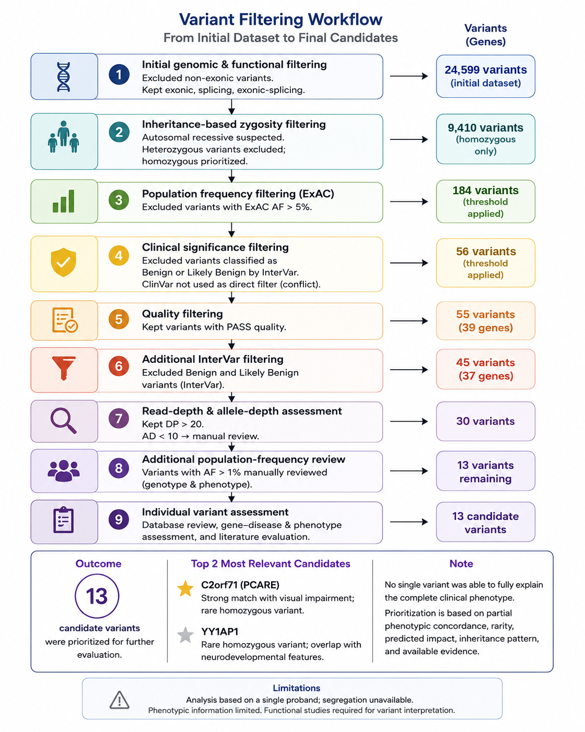
Figure 2. Summary of the stepwise variant filtering and prioritization workflow, from the initial dataset to the final candidate variants.

1. Unsel-Bolat G, Tezcan N, Genç-Akdağ D, Gerik-Celebi HB, Tezcan A, Bolat H. A novel compound heterozygous YY1AP1 1. Unsel-Bolat G, Tezcan N, Genç-Akdağ D, Gerik-Celebi HB, Tezcan A, Bolat H. A novel compound heterozygous YY1AP1 variant in Grange syndrome: importance of early signs in preventing life-threatening vascular complicat. J Hum Genet [Internet]. 2026 Aug 1 [cited 2026 Sep 7];71(8):485. Available from: https://pmc.ncbi.nlm.nih.gov/articles/PMC13400299/
2. Full article: Epigenetic regulation of autophagy-related genes: Implications for neurodevelopmental disorders [Internet]. [cited 2026 Sep 7]. Available from: https://www.tandfonline.com/doi/10.1080/15548627.2023.2250217?url_ver=Z39.88-2003&rfr_id=ori:rid:crossref.org&rfr_dat=cr_pub 0pubmed#d1e202
3. Collin RWJ, Safieh C, Littink KW, Shalev SA, Garzozi HJ, Rizel L, et al. Mutations in C2ORF71 Cause Autosomal-Recessive Retinitis Pigmentosa. Am J Hum Genet [Internet]. 2010 May 14 [cited 2026 Sep 7];86(5):783–8. Available from: https://pubmed.ncbi.nlm.nih.gov/20398884/
4. Sopena-Pinilla M, Arruebo-Muñio M, Arias-Alvarez M, Arcas-Carbonell M, Tejada-González P, Lahuerta-Pueyo C, et al. Cone-Rod Dystrophy PCARE-Associated Retinopathy. Diagnostics (Basel, Switzerland) [Internet]. 2026 Jun 23 [cited 2026 Sep 7];16(13):1945. Available from: https://pubmed.ncbi.nlm.nih.gov/42449727/
5. Nishimura DY, Baye LM, Perveen R, Searby CC, Avila-Fernandez A, Pereiro I, et al. Discovery and Functional Analysis of a Retinitis Pigmentosa Gene, C2ORF71. Am J Hum Genet [Internet]. 2010 May 14 [cited 2026 Sep 7];86(5):686–95. Available from: https://pubmed.ncbi.nlm.nih.gov/20398886/
6. Pederzolli M, Servillo A, Sacconi R, Bandello F, Querques G. Bilateral macular colobomata: expanded phenotype of PCARE/C2ORF71. Ophthalmic Genet [Internet]. 2025 [cited 2026 Sep 7];46(5):483–8. Available from: https://pubmed.ncbi.nlm.nih.gov/40400237/
7. Zhao TT, Huang W, Lin K. Pum3 is dispensable for mouse oocyte maturation and embryo development in vitro. Zygote [Internet]. 2023 Aug 1 [cited 2026 Sep 7];31(4):359–65. Available from: https://pubmed.ncbi.nlm.nih.gov/37194574/
8. Tsukada YI, Ishitani T, Nakayama KI. KDM7 is a dual demethylase for histone H3 Lys 9 and Lys 27 and functions in brain development. Genes Dev [Internet]. 2010 Mar 1 [cited 2026 Sep 7];24(5):432. Available from: https://pmc.ncbi.nlm.nih.gov/articles/PMC2827838/

